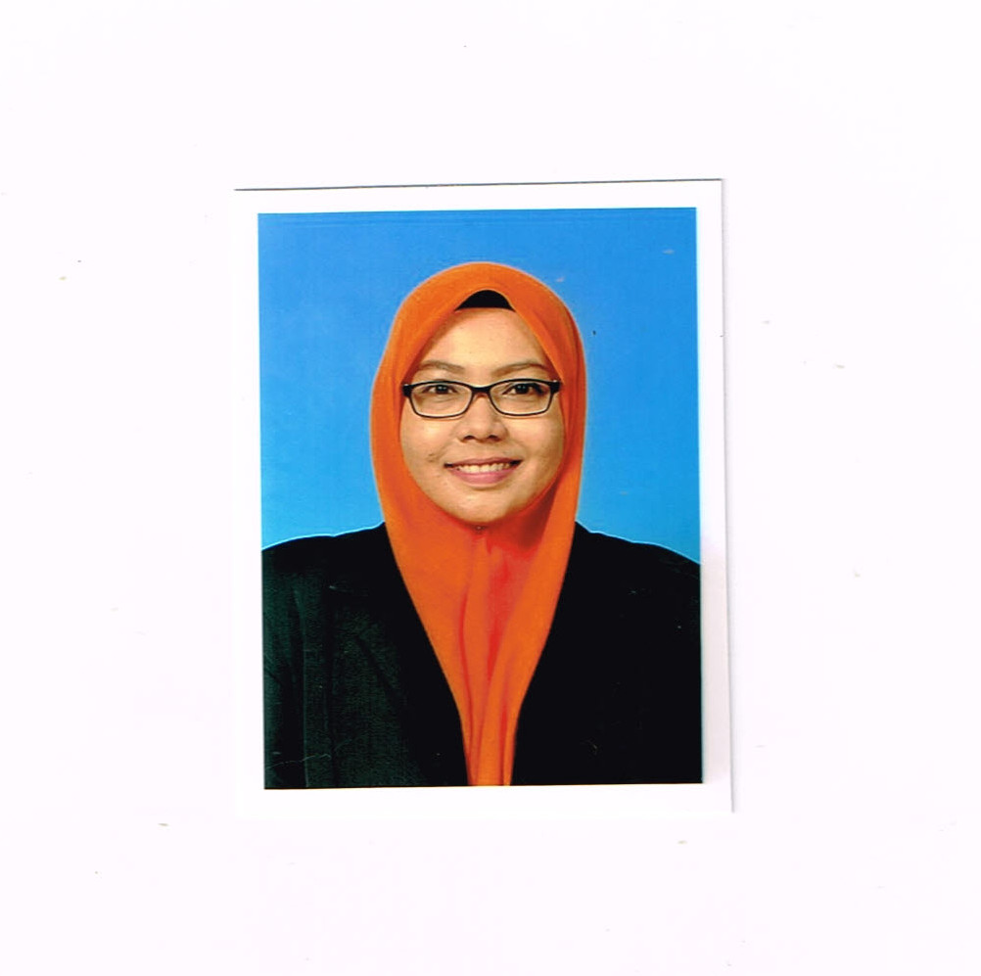

**NURUL AIN AFFIKAH BINTI BAHARIN**

**CONTACT**

Address : L4B Apartment Taman Kajang Sentral

Jln Tks 5 43000 Kajang Selangor

NRIC : 900303-03-5504

Phone (Mobile) : 014 - 5344541 / 07-9330083

E-mail : ainaffikah@gmail.com

Graduation Date : November 2010

**PERSONAL PARTICULARS**

Full name : Nurul Ain Affikah binti Baharin

I/C No. : 900303-03-5004

Gender : Female Age : 26 years

Nationality : Malaysian P.O.B : Kelantan

D.O.B : 03 March 1990 Race : Malay

Religion : Islam Nationality : Malaysia

Status :

Expacted Salary:RM 1500/negotable

**EDUCATION BACKGROUND**

Highest Education

Level : London Chamber Of Commerce & Industry Qualitication

(LCCIQ)

Collage : Institut Profesional Baitulmal Kg Pandan,Wilayah Persekutuan

Kuala Lumpur

Secondary Schools

Level : SPM

School : Sekolah Menengah Kebangsaan Tok Janggut Pasir Puteh Kelantan

Level : PMR

School :Sekolah Menengah Kebangsaan Tok Janggut Pasir Puteh Kelantan

Primary School

Level : UPSR

School : Sekolah Rendah Kebangsaan Kamil 3

**SKILLS AND STRENGTHS**

1. Can work in a team, hardworking and able to work in irregular hour
2. Able to communicate moderately in Oral/ Written in Bahasa Melayu and English
3. Computer Literacy (Microsoft Word, Access, Power Point, Excel,Publisher,etc)
4. Controlled items of stocks
5. Maintain relation in customer service
6. Reported sales by database
7. Fast learner and able to work under pressure.
8. Highly motivated, creative and willing to travel.

**WORKING EXPERIENCES**

1. Sales Assistant Iris Jewellery (Maju Junction Mall)
2. Sales Assistant (Pasaraya Econjaya Pasir Puteh)
3. Teacher (Taska Kementerian Kerja Raya)
4. Part Time Econjaya (Pasaraya Econjaya Pasir Puteh)
5. Part Time Typist (Dewan Bahasa & Pustaka)
6. Part Time Packaging Publication (Alex Publication Maluri)
7. Admin Assistant (Yetsmart Sdn Bhd Kuala Lumpur)
8. Teacher (Tadika Si Kecil -Little One’s Eduworld Pre- School)
9. Tutor ( Pelangi Computer Sdn Bhd – Kuantan)
10. Admin ( Parlimen Kuantan )
11. Admin (Teamcon Engineering Sdn Bhd )
12. Vistana Kuantan Centre ( F & B Department )
13. Part Time Teacher (Tadika Kemas Kuantan)
14. Assitant Manager (MSN Networking Technologies Sdn Bhd)
15. PSH Pembantu Perangkaan Gred E 17 (Jabatan Perangkaan Selangor (PO KAJANG)

**REFERENCES**

1. Sazli bin Salim

F & B Supervisor Vistana Hotel Kuantan

Jalan Teluk Sisek 25000 Kuantan Pahang.

011-19473061

1. Mohd Ridzal Bin Mohd Noor

Pembantu Perangkaan E22

Jabatan Perangkaan Selangor ( PO KAJANG )

43000 Kajang Selangor

019-2301970